Laboratory Practical Report

of

**DATA STRUCTURE AND ALGORITHM**

**(ICT ED 435)**

Submitted To

**TRIBHUVAN UNIVERSITY**

In Partial Fulfillment of the Requirements of the course

**B.Ed. ICTE 3rd Semester**

Submitted By

Sanam Tamang

Symbol No.: 76214020

T.U. Regd. No.: 9-2-0214-0054-2019

Under the guidance of

**Mr. Dharma Kumari Kalakheti**

Faculty Member, BICTE Program

Sukuna Multiple Campus

Sundarharaincha-12, Morang

(Internal Examiner)

Submitted for the Final Examination on: 2078/12/29

_________________

(External Examiner)

Q.n1: Create on word processor software for making text formatting, pages setting, table and object insert, review and documentation ?

Solution:

A: Text formatting:

Formatting refers to the way our text will look like – the design of the characters, their size, the space between paragraphs, their alignment, etc. First, selection of text.

• By using the mouse, position the insertion point (by clicking the mouse) at the beginning or end of the block to be selected and then click and drag to the end or beginning of the block.

• By using the shortcuts:

* + - * + Double-click on a word to select it.
        + Triple-click on a paragraph to select it.
        + Ctrl+click on a sentence to select it.

There are basically two types of formatting:

• Character formatting, and

• Paragraph formatting

B: pages setting:

Word offers a variety of page layout and formatting options that affect how content appears on the page. You can customize the page orientation, paper size, and page margins depending on how you want your document to appear. Select the Layout tab.

Click the Orientation command in the Page Setup group.

A drop-down menu will appear. Click either Portrait or Landscape to change the page orientation.

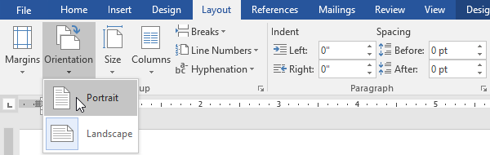

The page orientation of the document will be changed.

C: Table and object:

For a basic table, click Insert > Table and move the cursor over the grid until you highlight the number of columns and rows you want.

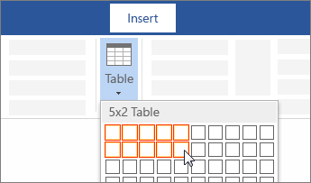

For a larger table, or to customize a table, select Insert > Table > Insert Table.

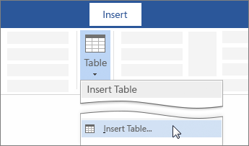

•A Word Processor text object can be formatted using BarTender's Word Processor, an easy-to-use interface that enables you to modify the content of the text object.

•Single and Multi-line text boxes will apply formatting to the entire object; this prevents formatting such as bolding individual words in the object; the entire text object would be bold.

• The Word Processor object allows different formatting within the same object.

• Word Processor objects are printed as an image, so they require quite a bit more resources than a normal Single or Multi-line text object.

•It is recommended to only use Word Processor objects when necessary.

D: Insert

Insert Tab It did not go anywhere….it has now been converted to a tab, the Insert Tab! It now has some more features. The Insert tab contains various items that you may want to insert into a document.  These items include such things as tables, word art, hyperlinks, symbols, charts, signature line, date & time, shapes, header, footer, text boxes, links, boxes, equations and so on.    Insert and Format a Picture

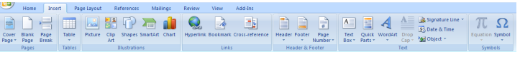

D: review

The Review tab provides icons for document review-related commands, such as spelling check, translation, track changes, apply changes, comments and so on.

Final with Markup

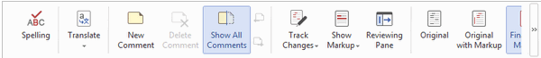

Q.n2: Design and use spread sheet for recording the following table of students performance ?

Solution:



Q.n3: Design Power point for creating inserting pictures, charts, audio, video, formatting presentation, layout, animation, slide transition and explain all of them with the stepwise, show each steps in the figures with print screen or copy of the pages.

Solution:   
Insert a picture in PowerPoint

Depending on which version of PowerPoint you're using, you can insert pictures, photos, clip art, or other images to your slide show from your computer or from the Internet.

Insert a picture from your computer on your slide

Click where you want to insert the picture on the slide.

On the Insert tab, in the Images group, click Pictures and then click This Device.

In the dialog box that opens, browse to the picture that you want to insert, click that picture, and then click Insert.

Insert stock images on your slide

Click where you want to insert the picture on the slide.

On the Insert tab, in the Images group, click Pictures and then click Stock Images.

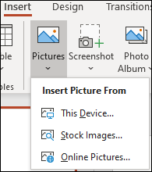

Type in what image you're looking for, then click on which images you want and click Insert.

Insert a picture from the web on your slide

Click where you want to insert the picture on the slide.

On the Insert tab, in the Images group, click Pictures and then click Online Pictures.



In the search box type in the image you're looking for and press enter.

Select all the images you want and then click Insert.

Chart:

To create a simple chart from scratch in PowerPoint, click Insert > Chart and pick the chart you want. On the Insert tab, in the Illustrations group, click Chart. In the Insert Chart dialog box, click the arrows to scroll through the chart types. Select the type of chart that you want and then click OK.

Click Insert > Chart.

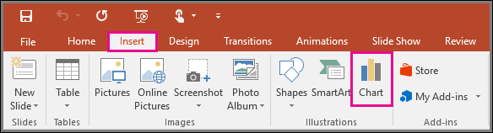

Click the chart type and then double-click the chart you want.

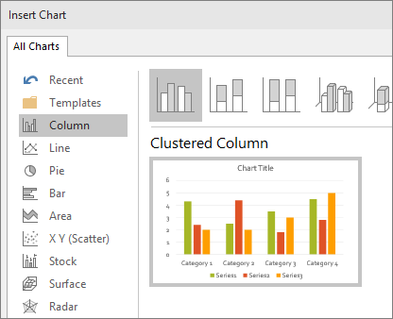

In the worksheet that appears, replace the placeholder data with your own information.

When you insert a chart, small buttons appear next to its upper-right corner. Use the Chart Elements Chart Elements button button to show, hide, or format things like [axis titles](https://support.microsoft.com/en-us/office/add-or-remove-titles-in-a-chart-4cf3c009-1482-4908-922a-997c32ea8250) or [data labels](https://support.microsoft.com/en-us/office/add-or-remove-data-labels-in-a-chart-884bf2f1-2e29-454e-8b42-f467c9f4eb2d). Or use the Chart Styles Customize the Look of Your Chart button button to quickly [change the color or style of the chart](https://support.microsoft.com/en-us/office/add-or-remove-titles-in-a-chart-4cf3c009-1482-4908-922a-997c32ea8250).

When you’ve finished, close the worksheet.

Audio: in your PowerPoint presentation. You can add audio, such as music, narration, or sound bites, to your PowerPoint presentation. To record and hear any audio, your computer must be equipped with a sound card, microphone, and speaker’s .Add audio from your PC

Select Insert > Audio.

Select Audio on My PC.

In the Insert Audio dialog box, select the audio file you want to add.

Select Insert.

Record audio

Select Insert > Audio.

Select Record Audio.

Type in a name for your audio file, select Record, and then speak.

To review your recording, select Stop and then select Play.

Select Record to re-record your clip, or select OK if you're satisfied.

To move your clip, select and drag the audio icon to where you want it on the slide.

If you’re using more than one audio file per slide, we recommend putting the audio icon in the same spot on a slide to find it easily.

Select Play

.Change playback

options Select the audio icon and then select the Audio Tools Playback tab. Then select which options you'd like to use:

To trim the audio, select Trim and then use the red and green sliders to trim the audio file accordingly.

To fade in or fade out audio, change the number in the Fade Duration boxes.

To adjust volume, select Volume and select the setting you prefer.

To choose how the audio file starts, select the dropdown arrow and select an option:

In Click Sequence: Plays the audio file automatically with a click.

Automatically: Plays automatically once you advance to the slide that the audio file is on.

When Clicked On: Plays audio only when the icon is clicked on.

To choose how the audio plays in your presentation, select an option:

Play Across Slides: Plays one audio file across all slides.

Loop until Stopped: Plays an audio file on loop until it’s stopped manually by clicking the Play/Pause button.

To have the audio play continuously across all slides in the background, select Play in Background

This is a guide to show you how to insert audio from your computer into your PowerPoint Presentation.

1. First, navigate to the slide you'd like to insert the audio on. Click the "Insert" tab on the ribbon menu.

2. Click the "Audio" button in the top right corner, then select "Audio on My PC..." from the drop-down menu.

3. File Explorer will open. Browse to the audio file you'd like to include, click it, and select the "Insert" button.

4. The audio file will appear as a small icon which you can click and drag. To change the playback settings and other options, click the "Playback" button in the "Audio Tools" section of the ribbon.

Video:

Click on the slide you want, then go to Menu > Insert.

In the top right corner, click Video > Video on My PC.

Find the video you want to add and click “Insert”.

Adjust the settings in the Video Format toolbar to make sure it plays the way you want. For example, if you want your video to take center stage as soon as you click on the slide, make sure you select “Play Full Screen” and “Start Automatically”.

5. Preview your presentation to check your video plays exactly how you want it to. That’s it! You’re done.

Formatting presentation:

PowerPoint formatting is transforming a rough presentation into something more beautiful and presentable to the audience. It can also be described as a process where slides are given a facelift.

Following are the most offered presentation format available with any presentation designing agency.

PowerPoint Presentation or Keynote.

Flash or Interactive or Multimedia Presentation.

Video /AV/ Film.

Whiteboard Presentation.

Hybrid Presentation.

Layout: A slide layout is an arrangement of placeholders, which are designed to help you position your slide content. The layout refers to the way that the objects are arranged on the slides. A slide layout will contain placeholder for particular objects (e.g. text, charts, clipart etc.).

Animation: In the simplest sense, animation is something that makes slide objects move on a slide. And slide objects can be anything on a slide. These include text, pictures, charts, SmartArt graphics, shapes, even movie clips

Slide transition: Slide transitions are the animation-like effects that happen when you move from one slide to the next during a presentation. Add slide transitions to bring your PowerPoint presentation to life. Select the slide you want to add a transition to. Select the Transitions tab and choose a transition. In the PowerPoint presentation, click the slide you want to add a transition to in the left preview [pane](https://www.computerhope.com/jargon/p/pane.htm).

In the [Ribbon](https://www.computerhope.com/jargon/r/ribbon.htm), click the Transitions tab.

On the *Transitions* tab, in the *Transition to This Slide* section, select the desired slide transition. When you select a transition, a [preview](https://www.computerhope.com/jargon/p/preview.htm) of the transition for the selected slide is displayed.

Q.n4: Define “google drive” and “Skype” explaining how and why you use them in brief and create a Google drive of you own and present its screen print on the word file. Also, mention their advantages and disadvantages?

Solution: Google Drive is a cloud-based storage solution that allows you to save files online and access them anywhere from any smartphone, tablet, or computer. You can use Drive on your computer or mobile device to securely upload files and edit them online. Drive also makes it easy for others to edit and collaborate on files. Google Drive is a [file storage](https://en.wikipedia.org/wiki/File_hosting_service) and [synchronization service](https://en.wikipedia.org/wiki/File_synchronization) developed by [Google](https://en.wikipedia.org/wiki/Google). Launched on April 24, 2012, Google Drive allows users to store files in the [cloud](https://en.wikipedia.org/wiki/Cloud_storage) (on Google's servers), synchronize files across devices, and [share files](https://en.wikipedia.org/wiki/File_sharing). In addition to a [web interface](https://en.wikipedia.org/wiki/Web_application), Google Drive offers apps with offline capabilities for [Windows](https://en.wikipedia.org/wiki/Microsoft_Windows) and [macOS](https://en.wikipedia.org/wiki/MacOS) computers, and [Android](https://en.wikipedia.org/wiki/Android_(operating_system)) and [iOS](https://en.wikipedia.org/wiki/IOS) smartphones and tablets. Google Drive encompasses [Google Docs](https://en.wikipedia.org/wiki/Google_Docs), [Google Sheets](https://en.wikipedia.org/wiki/Google_Sheets), and [Google Slides](https://en.wikipedia.org/wiki/Google_Slides), which are a part of the [Google Docs Editors](https://en.wikipedia.org/wiki/Google_Docs_Editors) [office suite](https://en.wikipedia.org/wiki/Office_suite) that permits collaborative editing of documents, spreadsheets, presentations, drawings, forms, and more. Files created and edited through the Google Docs suite are saved in Google Drive.

Step 1: Go to drive.google.com

On your computer, go to [drive.google.com](https://drive.google.com/). You’ll see "My Drive," which has:

Files and folders you upload or sync

Google Docs, Sheets, Slides, and Forms you create

Step 2: Upload or create files

You can upload files from your computer or create files in Google Drive.

[Upload files and folders to Google Drive](https://support.google.com/drive/answer/2424368)

[Work with Office files](https://support.google.com/docs/answer/6055139)

[Create, edit, and format Google Docs, Sheets, and Slides](https://support.google.com/docs/topic/1361461)

Step 3: Share and organize files

You can share files or folders, so other people can view, edit, or comment on them.

[Share files from Google Drive](https://support.google.com/drive/answer/2494822)

[Share folders from Google Drive](https://support.google.com/drive/answer/7166529)

[Make someone else the owner of a file](https://support.google.com/drive/answer/2494892)

Advantages:

Ability to Access Files from Everywhere. ...

Ability to edit files. ...

Compatibility with most devices. ...

Quick Files Search. ...

Ability to view different file types. ...

Easy sharing. ...

Open discussion. ...

Free Storage space of up to 15 GB.

Disadvantages of Google Drive

Security Risks. ...

Requires Internet connection. ...

Has a limit of file size you can upload in a day. ...

File size limits. ...

Erratic Third-party applications. ...

Downloading and uploading speed. ...

Google broses content save in Google drive.

Skype is software that enables the world's conversations. Millions of individuals and businesses use Skype to make free video and voice one-to-one and group. Skype was founded in 2003 by [Niklas Zennström](https://en.wikipedia.org/wiki/Niklas_Zennstr%C3%B6m), from  [Sweden](https://en.wikipedia.org/wiki/Sweden), and [Janus Friis](https://en.wikipedia.org/wiki/Janus_Friis), from [Denmark](https://en.wikipedia.org/wiki/Denmark)., The Skype software was created by Estonians [Ahti Heinla](https://en.wikipedia.org/wiki/Ahti_Heinla), [Priit Kasesalu](https://en.wikipedia.org/wiki/Priit_Kasesalu),  [Jaan Tallinn](https://en.wikipedia.org/wiki/Jaan_Tallinn), and Toivo Annus. Step 1: Download the software.

A step-by-step guide on how to use Skype

Step 2: Create your username. ...

Step 3: Set up your contact list. ...

Step 4: Select your call type. ...

Step 5: Make sure you're connected. ...

Step 6: Talk for as long as you want! ...

Step 7: End the call.

Skype is a hybrid instant messaging and voice chat application that allows users to connect with one another from any global location with Internet access. With over 663 million users, 1: Building Relationships

2: Instant Messaging

3: Low Cost

4: Flexibility

5: Tiny chat

6: Multi-Party Audio / Visual Conference Calling Reliability. ...

7: Audio / Visual Integration.

8: More Than 2 People in a Meeting Room for Video Conferencing.

Disadvantages: There is a risk of the technical issues of skype, as when there are dropped connections, the camera malfunctions and choppy video streams , it will quickly make a video conference frustrating or useless.

There is a loss of interpersonal connections as you can see everyone on the chat, and the government could potentially enable this program with wiretapping capabilities, The sound quality of using Skype may not be good, and you have to pay for some services on the Skype.

1: Network Connection

2: Security

3: Risk for Children

Q :N 5:Define and list out Search engine and social media, Also show the icon representing various engines with the help their screen prints.

Solution: A search engine is a software program that helps people find the information they are looking for online using Keyword or phrases. Search engines are able to return results quickly-even with millions of websites online-by scanning the internet continuously and indexing every pages they find where a user enters a search term, the search engine looks at the website page title, contents and keywords it has indexed and uses algorithms to produce a list of site-with the most relevant websites at the top of the list. Top search engine are as fellow:

1: Duck Duck Go

2: Bing

3. Chrome

1: Social media are interactive Web 2.0

2: User-generated content

3: Users create service-specific profiles for app or website that are designed and maintained by the social media organization.

The list of social media are:

1: Facebook

2: Twitter

3: Linkedin

5: Pinterest

6: Flickr etc.